
Lab Report
Department: Department of Computer Science and Engineering
Course Title: Computer Networks Lab
Course Code: CSE0612314
Experiment No.: 03
Experiment Title: Routing Through Router.

Submitted to:
Teacher’s name: Trisha Sarkar
Designation: Lecturer
Department of CSE
UITS

Submitted by:
Student name: Badhon Kumar Roy
Student Id: 04324205101042
Section: 5A2
Semester: Autumn 2026
Batch: 56th
Date of Submission: 05 September, 2026

Laboratory Report
1. Experiment Number: 03
2. Experiment Title: Routing Through Router.

3. Objectives:
- To learn how a router connects and routes traffic between two different networks.
- To understand the difference between switch-based communication and router-based communication.
- To design a network with two switches and a router in Packet Tracer.
- To assign IP addresses to devices on separate subnets and configure the router accordingly.
- To test and observe connectivity between devices across different networks using CMD ping and Simulation Mode.
4. Theoretical Background:
A router is a networking device used to connect two or more different networks and forward data between them based on IP addresses. Unlike a switch, which only works within a single network to deliver data to the correct device, a router looks at the destination IP address and decides the best path to send the data to another network entirely. In this experiment, two separate networks (197.168.42.x and 197.165.42.x) were connected through a router, with each network having its own switch and set of PCs. This setup made it possible to observe how devices on one network communicate with devices on a completely different network, which isn't possible with just a switch. Testing this through ping and Simulation Mode helped in understanding how routers manage traffic flow between networks.
5. Tools and Software used:
- Cisco Packet Tracer,
- PC-PT,
- PT8200 Router,
- 2960-24TT Switch,
- Wires.

6. Network Topology:
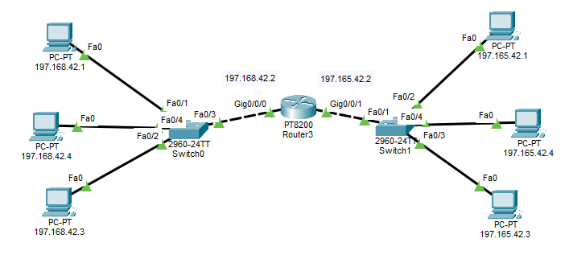
Figure 3.1: Two networks (197.168.42.x and 197.165.42.x) connected through a router via two switches.

7. Methodology:
- At first, we opened Cisco Packet Tracer and set up the workspace.
- Selected required devices like PCs, two Switches, and a Router from the device panel and placed them on the workspace.
- Connected PCs 197.168.42.1, 197.168.42.3, and 197.168.42.4 to Switch0.
- Connected PCs 197.165.42.1, 197.165.42.3, and 197.165.42.4 to Switch1.
- Connected Switch0 to the Router's Gig0/0/0 port and Switch1 to the Router's Gig0/0/1 port.
- Assigned IP addresses to all PCs according to their respective subnets (197.168.42.x and 197.165.42.x).
- Configured the router's interfaces with IP addresses 197.168.42.2 and 197.165.42.2 to enable routing between the two networks.
- Opened the Command Prompt on a PC (197.165.42.3) and used the ping command to test connectivity with a PC on the other network (197.168.42.1).
- Observed the ping replies and round-trip times to confirm successful communication across the router.
- Took screenshots of the topology and the CMD ping results for documentation. Took screenshots of the topology, the Simulation Mode results, and the CMD ping results for documentation.
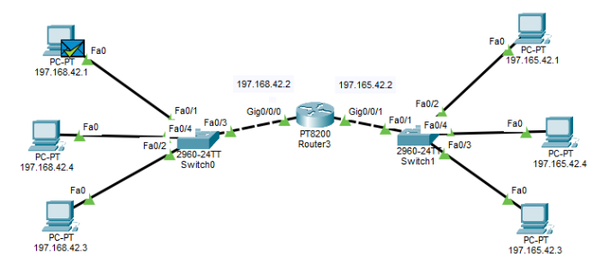
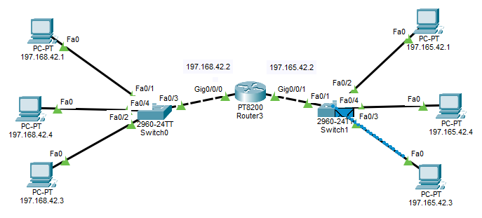
8. Output:

Figure 3.2: Simulation Mode – Packet traveling from 197.165.42.3 to 197.168.42.1 through the Router
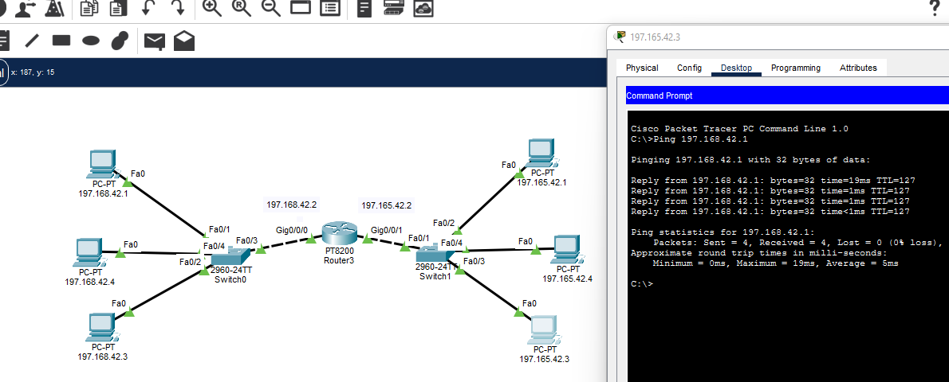
Figure 3.3: CMD Ping Results from 197.165.42.3 to 197.168.42.1
9. Conclusion:
This experiment helped in understanding how a router enables communication between two separate networks, unlike a switch which only works within a single network. By connecting two switches through a router and testing connectivity with ping, it became clear how the router directs traffic based on IP addresses to reach devices on a different subnet. The successful ping replies between 197.165.42.3 and 197.168.42.1 confirmed that the router was properly forwarding data between the two networks. Overall, the experiment gave a clear, hands-on understanding of how routing works and why routers are essential for connecting multiple networks together.

